📞 How to Place a Number Port on the Pragma Hub
This process should be followed only after the customer has been created on the iPECS portal.
The steps below will walk you through placing a number port request in the Pragma Hub.

🔐 Step 1: Log in and Start a Port Order
Log into the Pragma Portal.
Scroll down the left-hand menu to 'Number Porting' and click 'Create Port Order'. The number portability checker works the same as Gamma’s.
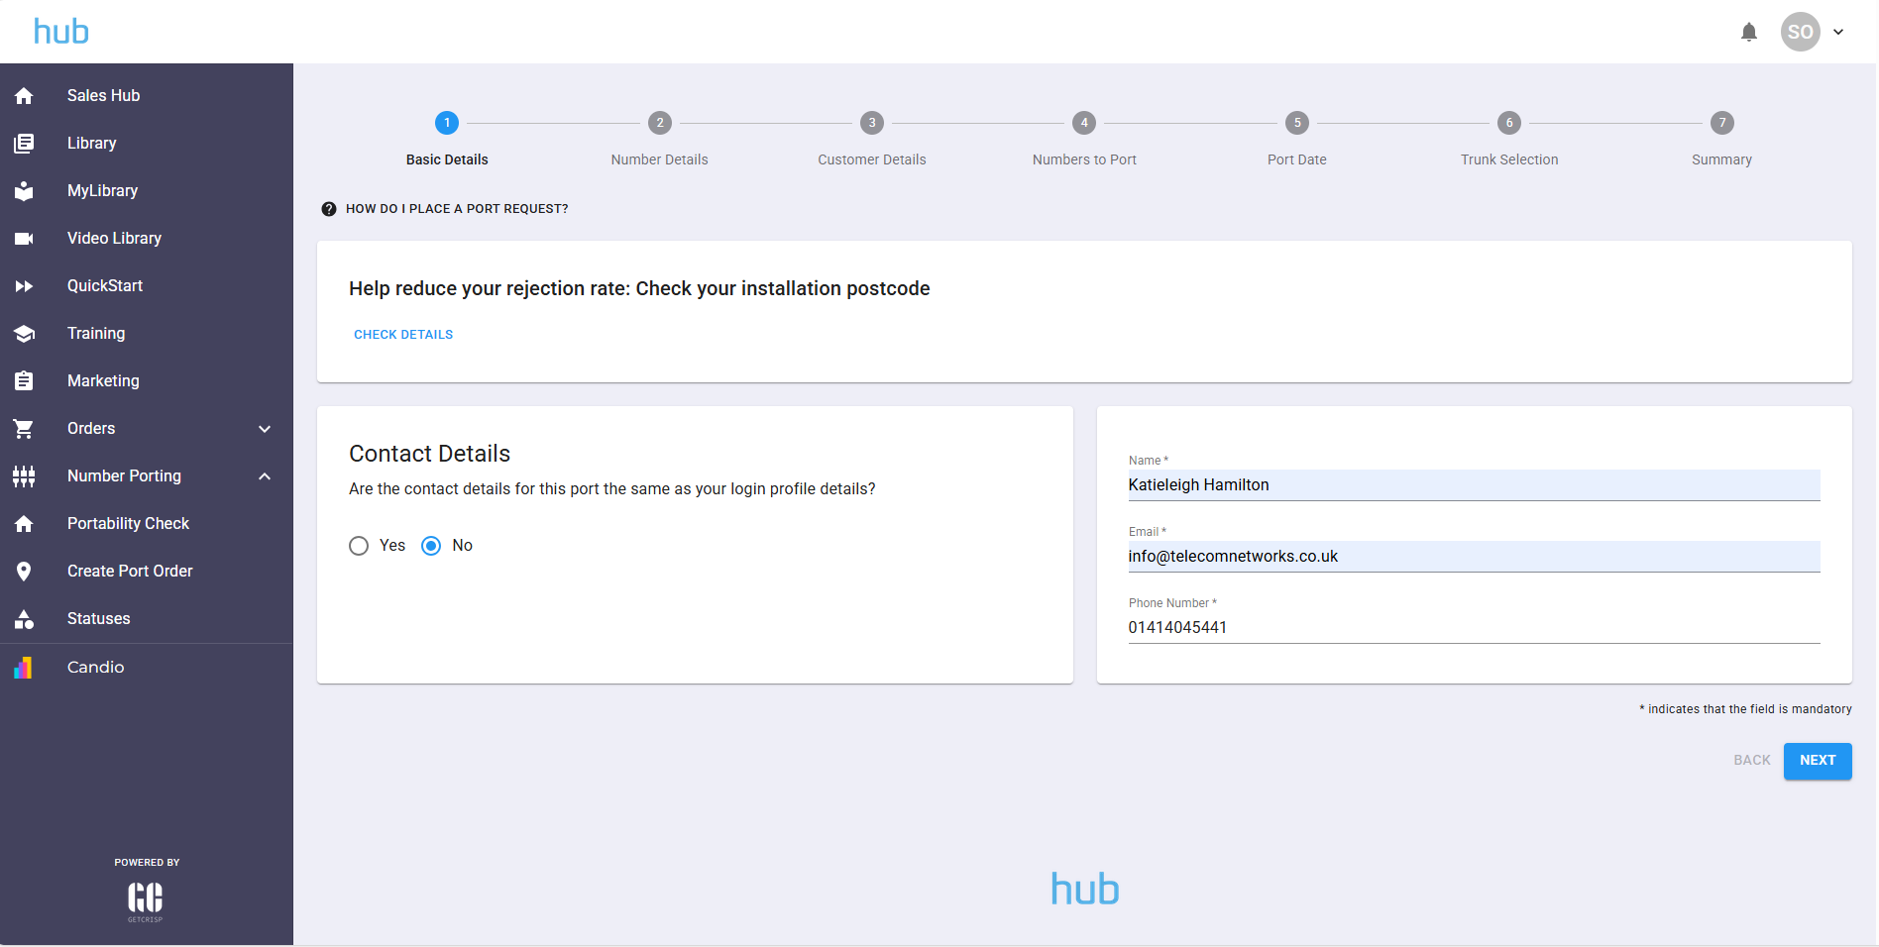

📧 Step 2: Enter Contact Details
Enter your contact details for the port order. Use your name, and use "info@telecomnetworks.co.uk" as the email. Then click 'Next'.
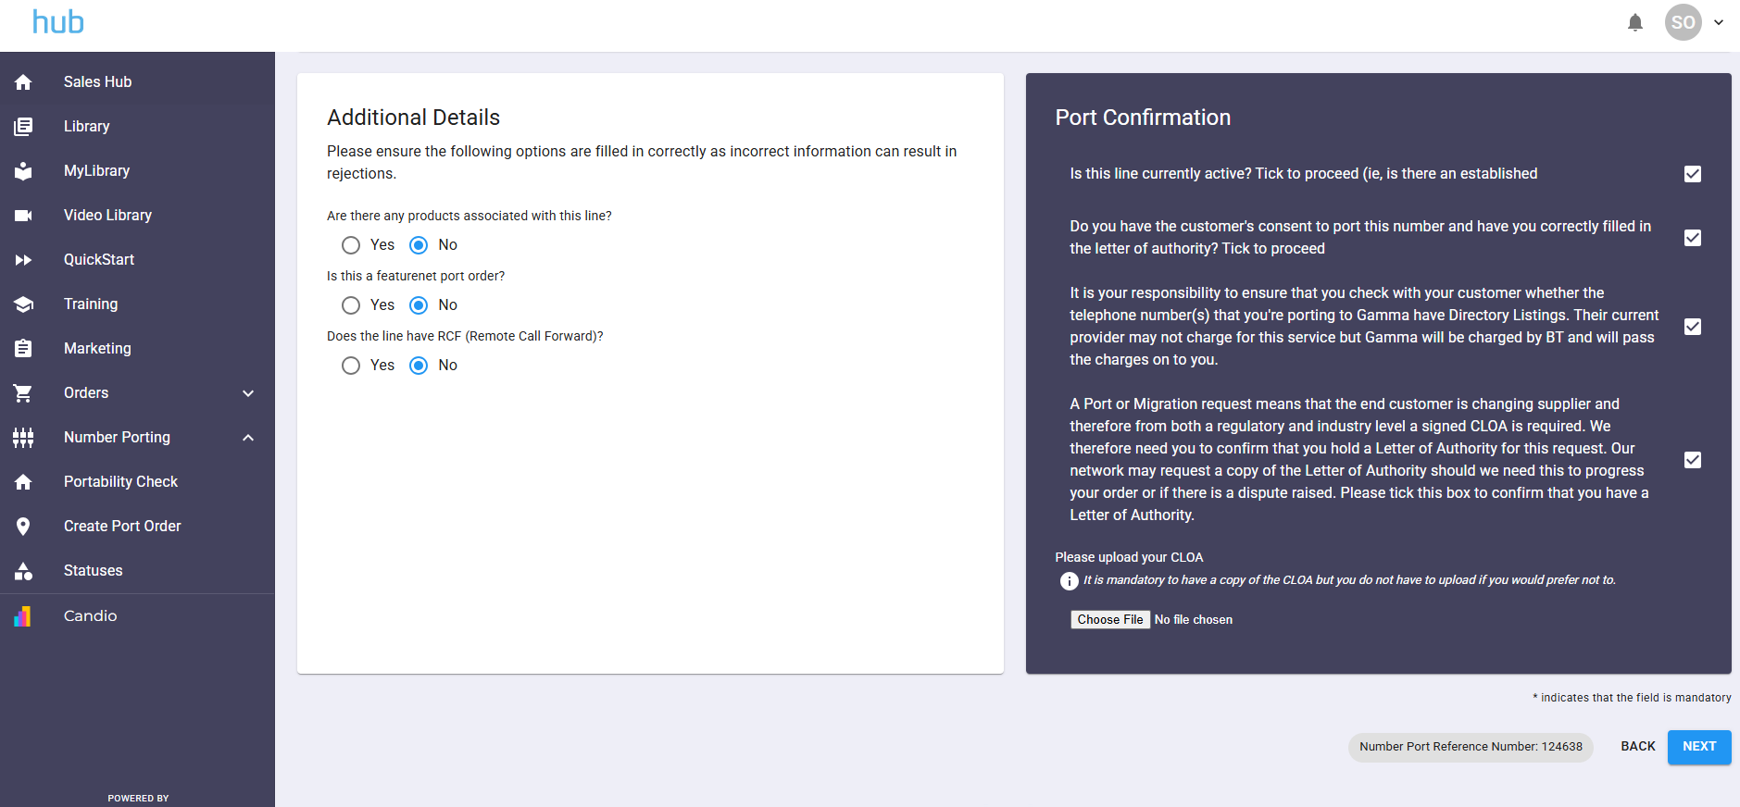

📄 Step 3: Enter Number & Porting Details
Enter the number details, including the losing provider. Account number can remain blank.
Fill in the additional details and tick all port confirmation checkboxes.
Then click 'Next'.
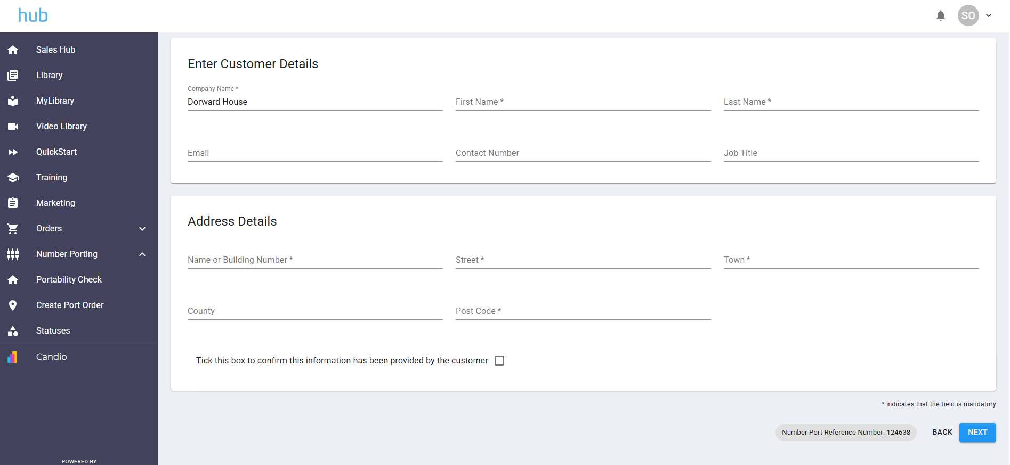

👤 Step 4: Enter Customer and Address Details
Fill in the customer details and ensure the address is accurate. These are used for 999 records.
Click 'Next'.
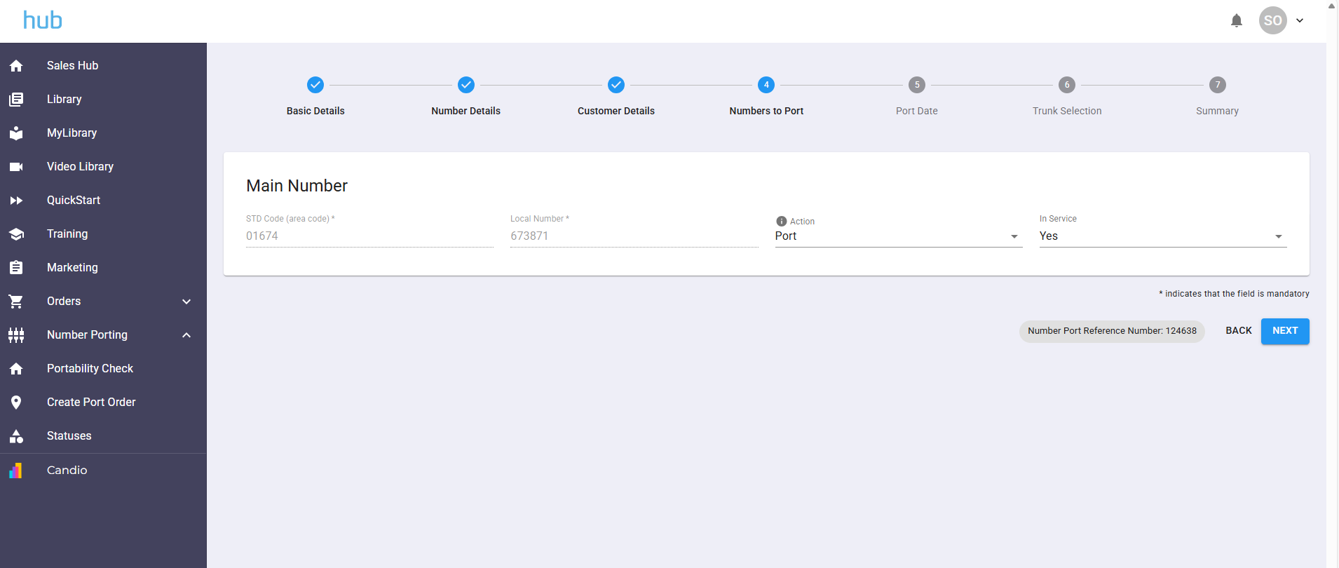

📞 Step 5: Confirm Numbers to Port
This page will populate automatically with number details.
Ensure the action is set to 'Port' unless advised otherwise.
Click 'Next'.
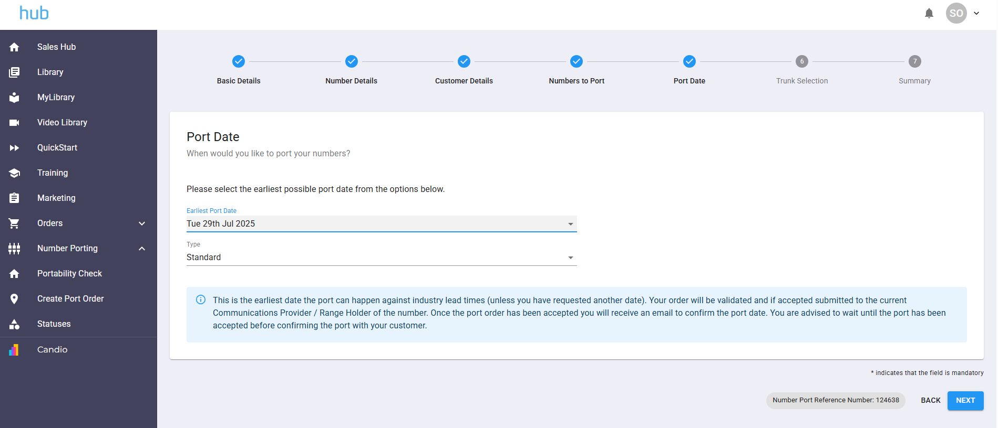

📅 Step 6: Select a Port Date
Always select your own port date. Do not leave the default 'earliest port date'.
The port type should always be 'Standard' unless otherwise stated.
Click 'Next'.
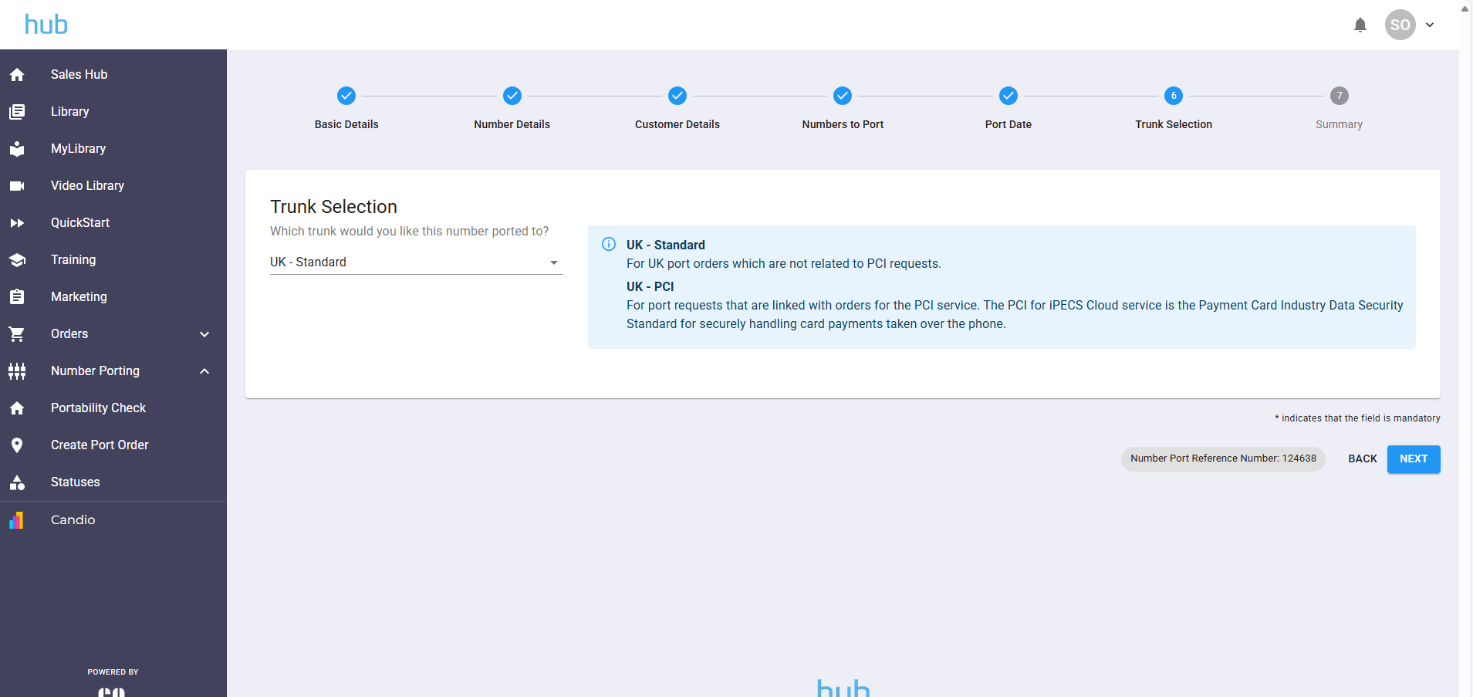

📡 Step 7: Trunk Selection
Select 'UK - Standard' unless you are instructed to choose another option.
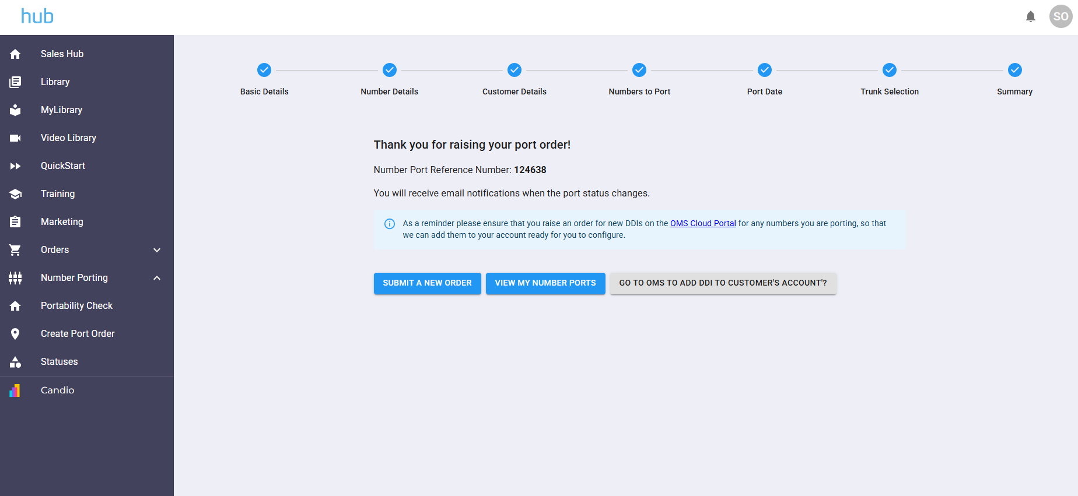

✅ Step 8: Submit and Record Port Order
Check all entered details carefully.
Then submit the port order. Once submitted, note the port reference number from the summary page.
Update the relevant CRM task with this number.
